**STUDENT ATTENDACE MONITORING SYSTEM**

**WITH QR CODE FOR LIBTONG ELEMTARY SCHOOL MEYCAUYAN CITY, BULACAN**

**Prepared By:**

**Camacho, Vien Mabee**

**Galvez, Sean Andrew**

**Java, Marjorie**

**Ortiz, Krisha Mae**

**INTRODUCTION**

Student Attendance Monitoring System with QR Code is a web-based application that allows schools and teachers to take attendance more effectively. Based on QR code scanning by students, this application will allow teachers to register attendance faster and more accurately.

**Brief Overview of the Project**

This application serves as an option to taking attendance manually, either through a manual call or when students choose to check themselves off. This application is accessible through a web browser for both students and teachers. Each student will have their designated QR code, and when they enter the classroom, they need to scan their QR code via the computer/laptop camera, and it will automatically take attendance.

**Background Information**

There are still some schools that utilize the traditional way of checking attendance. These methods are great, but they are time-consuming, and often, there is no proper monitoring, especially if students check themselves in and out without doing the same for their classmates. Furthermore, teachers with large sections may find it hard to take proper and accurate attendance. Therefore, there should be a way to monitor student attendance quickly and reliably, providing convenience.

**Objectives and Goals of the Project**

To make taking attendance faster and easier for teachers and students. To improve the accuracy of attendance records and reduce errors. To prevent students from signing in for someone else. To provide real-time attendance information for teachers and school staff. To make it simple to view and manage attendance records at any time.

**CLIENT INFORMATION**

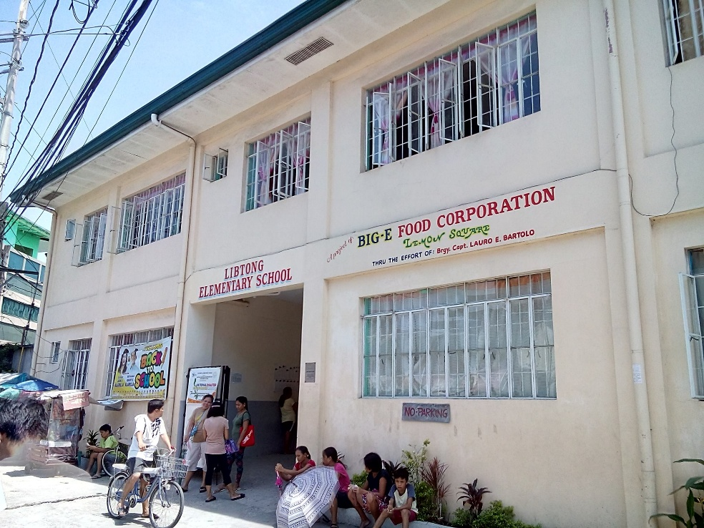**Client Organization Overview**

In Meycauayan City, Bulacan, on Bisita Street, Libtong Elementary School is a public elementary school, Offering K–6 basic education, it operates under the Department of Education Philippines and serves as a major center for foundational learning and community engagement. The school informs parents, students, and other stakeholders about announcements, events, and updates through official channels.

**Brief Description of the Client's Business and Industry**

Libtong Elementary School is a public school that follows the Philippine Department of Education's K-12 curriculum. It serves young students from the Meycauayan City community by providing foundational education in core subjects such as Filipino, English, Mathematics, Science, and Araling Panlipunan.

The school is critical in promoting child development, literacy, and values education at the barangay level. As part of the DepEd learning approach, it also engages in community outreach, health campaigns, and environmental programs.

**PROJECT SCOPE**

**Description of Specific Deliverables and Outcomes**

This project will create a web-based system that allows teachers to take attendance using QR codes, and it will work completely offline. The main results will be a website that runs on a teacher’s computer or laptop, a way for each student to get their own QR code, a feature for scanning QR codes to mark attendance, and pages where teachers can see and download attendance records. All attendance data will be stored safely on the teacher’s computer and can be accessed anytime, even without internet.

**Inclusions**

1. The system can be used without any internet connection.
2. The website runs locally on a teacher’s computer or laptop.
3. Each student gets a unique QR code.
4. Students can scan their QR code using the computer’s camera to mark themselves present.
5. Teachers can view and download attendance records.
6. All data is saved on the local computer.

**Exclusions**

1. The system will not work on mobile phones or tablets.
2. It will not support online or remote classes.
3. It will not connect to other school systems, like grading or scheduling.
4. It will not sync data between different computers automatically.

**Assumptions and constraints**

1. It is assumed that teachers have access to a computer or laptop with a working camera.
2. Students will bring their QR code (printed or on their phone) to class.
3. The system will only be used in the classroom and not for outside events.
4. The project must be finished within the time given by the school.

**PROJECT APPROACH**

**Overview of the Proposed Approach**

The goals of this project will be accomplished by creating a web-based attendance system that works fully offline. The layout of development will operate from a quasi-template. Each developmental step will be documented from planning to designing to coding to testing and, in the end, going live on the teacher's computer. Usability and practicality will be factors for the teacher and students.

**Methodology and Framework**

The **Student Attendance Monitoring System** is a simple computer program that helps record and track student attendance easily and correctly. It was made using the **Agile method**, which means it was improved step by step with feedback from users.

**Key activities and milestones**

**Planning and Requirements:** List all the features needed and how the system should

**work. Design:** Create simple sketches or diagrams of how the system will look and function.

**Development:** Build the system, including QR code generation, scanning, and attendance recording.

**Testing:** Try out all features to make sure they work correctly and fix any problems.

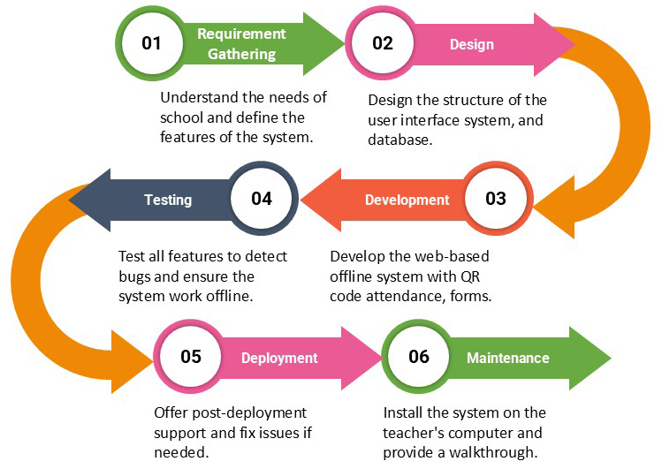**Deployment:** Set up the system on a teacher’s computer and make sure it runs without internet.

FIGURE 1

**Training and Handover:** Show teachers how to use the system and provide simple instructions.

**Key activities and milestones**

**Project Manager:** Java, Marjorie

**Lead Developer:** Camacho, Vien Mabee

**System analyst:** Galvez, Sean Andrew

**UI DESIGNER:** Ortiz, Krisha Mae

**Brief overview of their skill and experience**

**Project Manager (Marjorie Java):** Coordinates team and schedule, liaises with the school, ensures on-time delivery.

**Skills:** Planning/scheduling, leading meetings, tracking progress, stakeholder communication, basic reporting.

**Credentials:** Completed Project Management and Systems Analysis led class group projects.



**Lead Developer (Vien Mabee Camacho):** Builds the web app, integrates QR attendance and data storage, deploys locally, fixes issues.

**Skills**: Web dev with Python/Flask, HTML/CSS/JS, responsive UI, REST/JSON, SQLite/SQL Alchemy; AI-assisted development (Cursor/Warp/ChatGPT) for prototyping, refactoring, debugging, test suggestions.

**Credentials:** completed Web Dev and Database courses; built small Flask apps; uses AI coding tools in labs/group projects.



**System Analyst (Sean Andrew Galvez):** Gathers requirements, defines features and acceptance criteria, aligns the system with classroom needs.

**Skills:** Stakeholder interviews, requirements documentation, use case/ERD diagrams, SRS writing, feature prioritization.

**Credentials:** Completed Systems Analysis produced SRS and diagrams using Google Docs in past projects.



**UI Designer (Krisha Mae Ortiz):** Designs clear, usable screens, prototypes for feedback, refines UI for classroom use.

**Skills:** Wireframing/prototyping, clean layouts, basic responsiveness, basic accessibility (clear labels/contrast).

**Credentials:** Took UI/UX topics; created UI mockups for class projects (Canva/Figma) diagrams using Google Docs in past projects.

**PROJECT TIMELINE**

**High-Level Weekly Timeline**

This section includes a high-level weekly timeline for the Student Attendance Monitoring System with QR Code project. It breaks down the entire 2 months. Duration is divided into clear, structured phases, with each week's major activities and deliverable outlined.

|  |  |  |
| --- | --- | --- |
| **Week** | **Phase** | **Activities/Deliverables** |
| 1 | Requirements Gathering | Meet with teachers/school, list features, set goals |
| 2 | System Design | Plan system layout, user interface, and database |
| 3-4 | Development | Build the offline web-based system, QR code features |
| 5 | Testing | Try all features, fix bugs, make sure it works offline |
| 6-7 | Deployment | Install on teacher's computer, give walk through |
| Ongoing (as needed) | Maintenance | Support, fix issues if needed |

TABLE 1

1 1

**PROJECT RESOURCES**

This section contains the main resources needed for the successful planning, development, and implementation of Libtong Elementary - Meyacauyan Student Attendance Monitoring System with QR Code. It emphasizes the tools, technology, and those required to support each step of the project.

1. **Hardware Resources**

* At least one computer or laptop with a working camera (for teachers to run the system and scan QR codes).
* Printer (to print student QR codes).
* USB drive or external storage (for backups, if needed).

1. **Software Resources**

* Python (for running the web-based system).
* Flask and other required Python libraries (for the backend and web server).
* Web browser (such as Chrome, Firefox, or Edge) to access the system.
* QR code generator and scanner libraries (included in the system).
* SQLite (for the local database, included with Python).

1. **Human Resources**

* System Analyst (to gather requirements and plan the system).
* Project Manager (to oversee the project).
* UI Designer (to design the user interface).
* Lead Developer (to build and test the system).

**Budget allocation and justification**

1. **Hardware**

* Computer/laptop: Provided by the school (no extra cost if already available).
* Printer and paper: For printing QR codes (minimal cost).
* USB drive: Optional, for backups (minimal cost).

1. **Software**

* All required software and libraries are free and open-source, so there is no software cost.

1. **Human Resources**

* Team members are students on the project as part of their roles or coursework, so no extra salary is needed.

1. **Total Budget**

|  |  |  |  |
| --- | --- | --- | --- |
| **Category** | **Items** | **Cost** | **Responsibility** |
| Hardware | School PC/laptop with webcam; printer | 0 | School |
| Materials | Photocard paper + printer ink for QR codes | 605 | School |
|  |  |  |  |
|  | **TOTAL** | 605 | School |

**RISK MANAGEMENT**

Risk management for the Student Attendance Monitoring System focuses on identifying and addressing potential issues such as technical failures, user errors, and data security to ensure the system functions effectively and reliably.  
**Potential Project Risks**

|  |  |  |
| --- | --- | --- |
| **Category** | **Details** | **Risk** |
| 1. **Technical Issues** | The system might have bugs or errors that could stop it from working properly. Hardware problems such as a broken or malfunctioning computer/camera for QR code scanning. | Medium — can disrupt class sessions; fixes/workarounds usually available with time |
| 1. **Data Loss** | Attendance records could be lost if the computer is damaged or files are accidentally deleted. | High — loss of attendance history impacts reporting/compliance; recovery may be difficult |
| |  | | --- | | 1. **User Resistance** |  |  | | --- | |  | | Teachers or students might find it hard to use the new system or prefer the old manual attendance method. | Medium — slows adoption; addressed with simple UI and short training |
| 1. **Time Constraints** | The project might take longer than planned, especially if unexpected problems arise. | Medium — delays delivery; manageable with buffers and weekly tracking |

**Identified Risks and Mitigation Strategies**

|  |  |  |
| --- | --- | --- |
| **Identified Risk** | **Issue** | **Mitigation Strategy** |
| 1. **Hardware Problems** | Webcam/PC failure | Have a backup computer or camera available. Check all equipment before each use. |
| 1. **Data Loss** | Accidental deletion or device damage | Regularly back up attendance data to a USB drive or another secure locat |
| |  | | --- | | 1. **User Resistance** |  |  | | --- | |  | | Low adoption or hesitation to use the system | Provide simple instructions and training for teachers and students. Make the system as easy to use as possible. |
| 1. **Time Constraints** | Delays in development/testing/deployment | Follow a clear project plan and schedule. Set aside extra time for unexpected delays. |

TABLE 2

**COMMUNICATION PLAN**

The communication plan ensured effective collaboration through regular meetings, clear information sharing, and consistent coordination among all team members throughout the project.

**Communication Management Overview**

* Discord and Messenger, which allowed us to quickly coordinate tasks, share updates, and discuss progress in real-time.

**Meeting Schedule and Format**

* Project meetings were held once a week, conducted either through voice calls or group chats, depending on the urgency of tasks and availability of team members.

**Stakeholder Communication Preferences**

* Team members preferred Messenger for quick updates and daily coordination, Discord for more structured discussions and voice meetings, and Canva for collaborative editing of visual outputs and designs.

**PROJECT GOVERNANCE**

The project will be governed by the project manager, who is responsible for overseeing the team, ensuring tasks are completed on time, and maintaining effective collaboration. Regular meetings will be conducted to monitor progress and promptly address any issues.

**Decision Making Process**

For major decisions, the project manager will consult with the system analyst, UI designer, and lead developer, while significant changes or issues will be communicated to the school or teacher in charge.

**Roles and Responsibilities**

**Project Manager** (Marjorie Java):

* Leads the project, organizes meetings, assigns tasks, and makes final decisions.

**Lead Developer** (Vien Mabee Camacho):

* Builds the system, fixes technical issues, and ensures everything works as planned.

**System Analyst** (Sean Andrew Galvez):

* Makes sure the system meets the needs of the school and helps solve any problems that come up during the project.

**UI Designer** (Krisha Mae Ortiz):

* Designs the look and feel of the system and makes sure it is easy for teachers and students to use.

**School/Teacher** (Stakeholder):

* Gives feedback, helps test the system, and approves the final product